1. The best network for my RNN is my Keras Model as it gets an accuracy of 81% for both the testing data and training data. Attached in the file is Keras Code
2. There seems to be a problem with my implementation of the RNN as it gets an error with the negative number but the RNN seems to train correctly as the loss keeps going down with each iterations.
   1. A) For my keras model, I tried a lot of architectures starting with one LSTM Model with 4 Neurons and kept changing till I got two models with 82% Accuracy. The first model is one with a single LSTM Layer with 32 Neurons, and the second model is one with two LSTM Layers, each having 32 and 16 in this order.
   2. 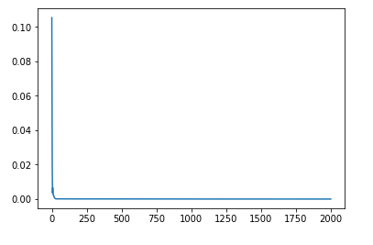
   3. My prediction for the next 5 days are as follows (average of both model’s predictions):
      1. 2725.88
      2. 2729.53225
      3. 2720.23
      4. 2724.5282
      5. 2728.799